*Introduction of an identifiers*

1. Explain about an identifier?
2. What are the rules for an identifier?

*Introduction of Keywords*

1. Explain about Keywords?

1. Write the list of keywords which are used in java programming language?
2. What are the major rules for writing keywords?
3. Write the list of keywords which are used for java files?
4. Write the list of keywords which are used for data types?
5. Write the list of keywords which are used for control structures?
6. What is “void” keyword?
7. What is “new” keyword?
8. Write the list of keywords which are used for accessibility modifiers?
9. Write the list of keywords which are used for modifiers?
10. Write the list of keywords which are used for object rep?
11. Write the list of keywords which are used for inheritance?
12. Write the list of keywords which are used for package?
13. Write the list of keywords which are used for Exception Handling?

*Introduction of an identifiers*

1. **Explain about an identifier?**

* Any name in java programming language is called an identifiers
* It may be class name, method name, variable name and label name.

1. **What are the rules for an identifier?**

* A java identifier is a sequence of characters, where each character may be a letter from a-z (or) A-Z (or) 0-9 (or) “$” (currency symbol) (or) “–” (connecting punctuation) , if we are using any other symbol we will get Compile time error “IllegalCharacter”.
* Identifier should not be starts with digit.
* There is no length limit for java identifiers, but it is not recommended to take more than 15 length.
* Java Identifiers are case sensitive.
* Reserved words (or) keywords should not use as an identifier.
* Interfaces and classes are also should not use as an identifier.

*Introduction of Keywords*

1. **Explain about Keywords?**

* **Java keywords** are also known as **reserved words**.
* Keywords are the special words which are reserved in java libraries.
* In java programming language we have 50 keywords among them 48 are in use.
* The keywords “**goto”** and “**const”** are not used in java programming language.

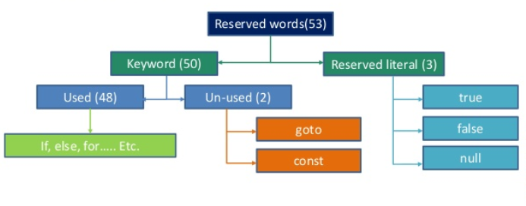

1. **Write the list of keywords which are used in java programming language?**

* The lists of keywords which are used in java programming language are shown in blow table.

1. **What are the major rules for writing keywords?**

* The major rule for writing keywords are

1. All the characters in the keyword must be small letters.
2. We can write more than one keywords in one statement.
3. **Write the list of keywords which are used for java files?**

* Among all the keywords in java, three keywords are used for java files they are
* class
* interface
* enum

1. **Write the list of keywords which are used for data types?**

* Among all the keywords in java, eight keywords are used for data types they are
* byte
* short
* int
* long
* float
* double
* char
* boolean
* All the above keywords are used for data types and also return type.

1. **Write the list of keywords which are used for control structures?**

* Among all the keywords in java, eleven keywords are used for control structures they are
* if
* else
* switch
* case
* default
* while
* do
* for
* break
* continue
* return
* In the above keywords if, else, switch, case, default keywords are used for decision making control structures.
* In the above keywords while, do, for keywords are used for looping control structures.
* In the above keywords break, continue and return keywords are used for transfer or control the flow of control structures.

1. **What is “void” keyword?**

* The void keyword is only used for return type.

1. **What is “new” keyword?**

* The new keyword is used for allocating memory space.
* This key word is called as memory allocation keyword.

1. **Write the list of keywords which are used for accessibility modifiers?**

* Among all the keywords in java, three keywords are used for accessibility modifiers they are
* private
* protected
* public

1. **Write the list of keywords which are used for modifiers?**

* Among all the keywords in java, eight keywords are used for modifiers they are
* final
* abstract
* native
* transient
* volatile
* synchronized
* strictfp
* static

1. **Write the list of keywords which are used for object representation?**

* Among all the keywords in java, three keywords are used for object representation they are
* this
* super
* instanceof

1. **Write the list of keywords which are used for inheritance?**

* Among all the keywords in java, two keywords are used for inheritance they are.
* extends
* implements

1. **Write the list of keywords which are used for package?**

* Among all the keywords in java, two keywords are used for packages they are.
* package
* import

1. **Write the list of keywords which are used for Exception Handling?**

* Among all the keywords in java, six keywords are used for Exception Handling they are.
* try
* catch
* finally
* throw
* throws
* assert